Monday 04th Sept 2023

IIM Jammu Orientation Program of the 3rd Batch of IPM: Day Three closes on grand note
By skilloutlook / September 4, 2023 / Comments Offon IIM Jammu Orientation Program of the 3rd Batch of IPM: Day Three closes on grand note
The final day of the three-day Orientation Program for IPM commenced with a relaxing yoga session focusing on the theme “Maximize Happiness and Mindfulness” led by Yoga Guru Sahil Mehra, following which the students departed for the Jagti campus. The session was coordinated by Team Anandam, IIM Jammu.
A brief overview of the social and corporate internships included in the IPM program by Dr. Baljeet Singh, Co-chairperson Placement, IIM Jammu, marked the beginning of the third day of the Orientation Program of the IPM 03 batch. He provided insights on what students should expect from the internships and suggestions to get maximum benefits and exposure. He also advised students to enhance their communication skills, which are vital for success in any organization.
Following this, there was an engaging and interactive session on ‘Teaching through Short Case Study’ by Dr. Mahesh Gadekar, Chairperson, Center for Small Business Development, IIM Jammu. During the presentation, he first elaborated on how to approach case studies with the help of examples and hypothetical cases. He also provided the students with the opportunity to practice the skills acquired during the session with the use of a case study.
Further in the program was an invigorating session comprised of Inbound & Outbound Activities for students facilitated by Dr. Barnali Chaudhary, Assistant Professor, IIM Jammu. The activities showcased the importance of communication, teamwork, plans, self-awareness, and leadership.
The post-lunch program commenced with a session on the topic ‘Branding IIM Jammu: The Role of Students’ by Prof. B.S. Sahay, Director, IIM Jammu. He reiterated to the students that all resources must be optimally utilized, emphasized on active listening, need for strict discipline along with having a positive frame of mind. He kickstarted the session by collecting feedback from IPM 03 batch along with inviting suggestions from the student fraternity on various ways to Brand IIM Jammu. He elucidated the teaching pedagogy at IIM Jammu and advised the students to make the best out of the course and the faculty provided to them.

This was followed by an informative session on business startups and funding for entrepreneurs by Dr. Muqbil Burhan, Chairperson, Center for Innovation and Entrepreneurship and Dr. Vivek Sharma, Chief Innovation Officer, Center for Innovation & Entrepreneurship, IIM Jammu. Dr. Muqbil Burhan started the session with a brief introduction about the ongoing projects and future of the Centre for Entrepreneurship Innovation & Skill Department IIM Jammu. Next, Dr. Vivek Sharma provided valuable insights on eligibility criteria for startup recognition, startup registration, eligibility criteria for income tax exemption, and types of startup funding.
The three-day Orientation Program of the IPM03 batch at the state-of-the-art Jagti Campus concluded on a positive note followed by cultural programs by Malhar Cultural Committee in coordination with Office of the Student Affairs, IIM Jammu.
https://skilloutlook.com/education/iim-jammu-orientation-program-of-the-3rd-batch-of-ipm-day-three-closes-on-grand-note

Tuesday 05th Sept 2023
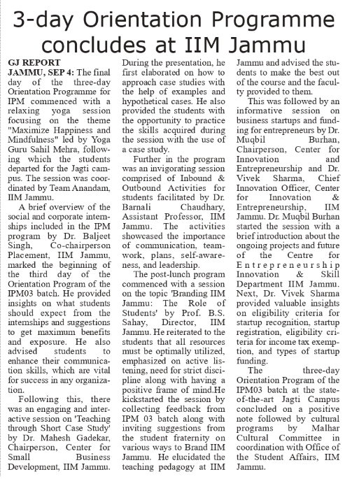

Tuesday 05th Sept 2023
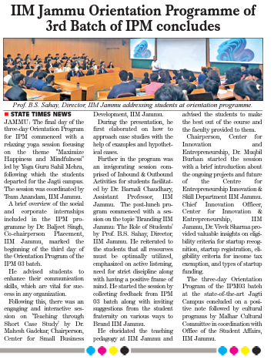

Tuesday 05th Sept 2023
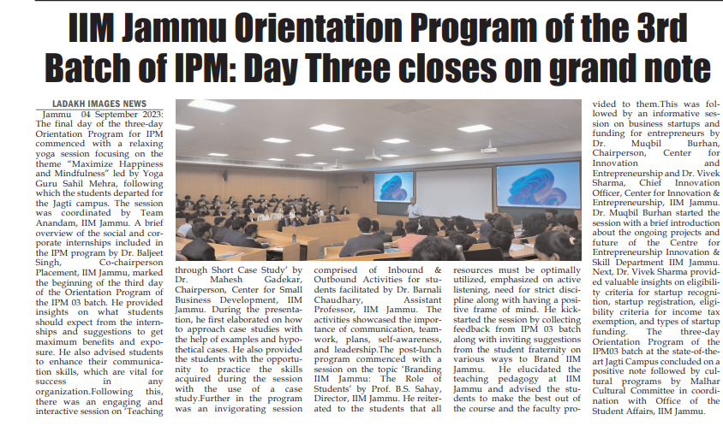

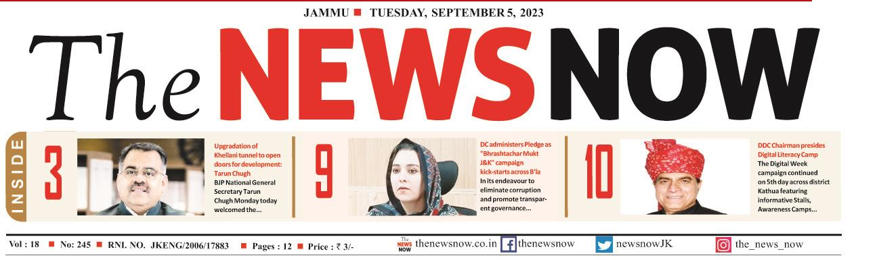
Tuesday 05th Sept 2023
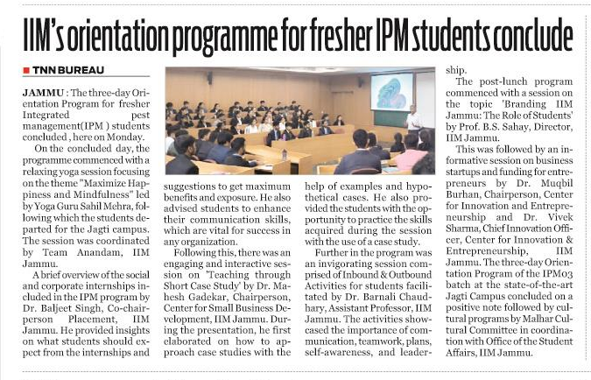

Tuesday 05th Sept 2023
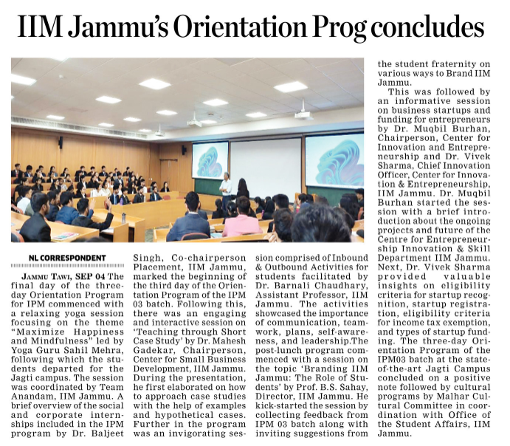

Tuesday 05th Sept 2023
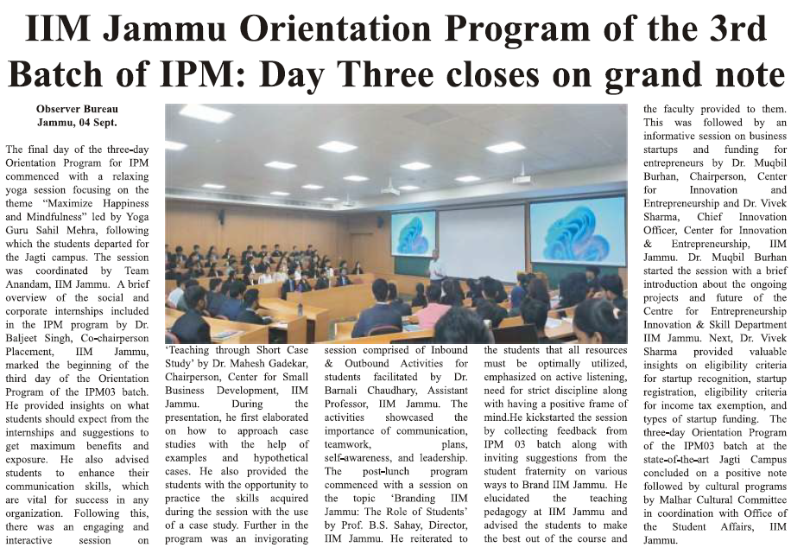

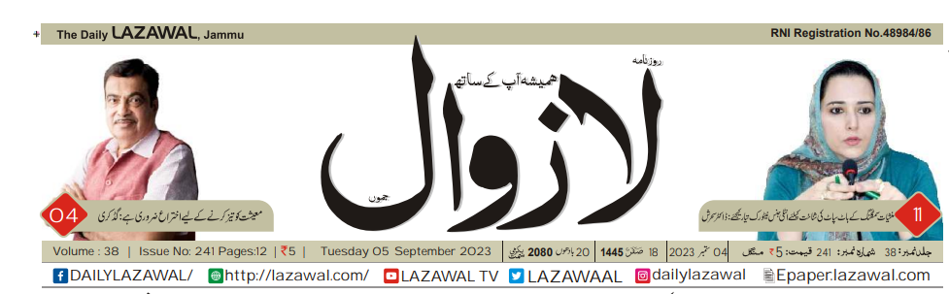
Tuesday 05th Sept 2023
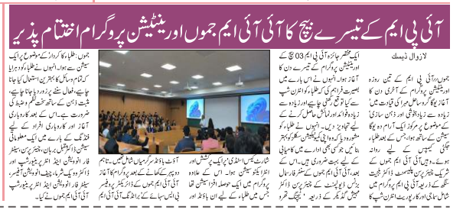

IIM Jammu Orientation Program of the 3rd Batch of IPM: Day Three closes on grand note

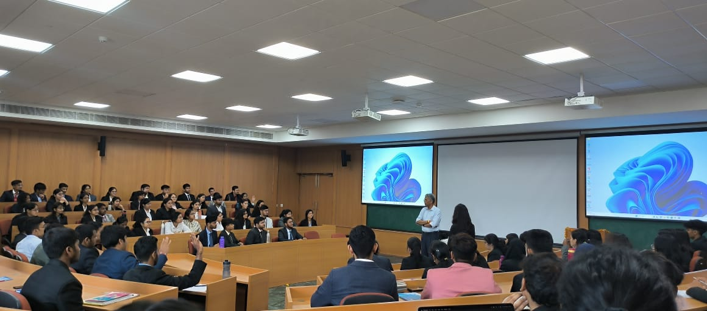
The final day of the three-day Orientation Program for IPM commenced with a relaxing yoga session focusing on the theme “Maximize Happiness and Mindfulness” led by Yoga Guru Sahil Mehra, following which the students departed for the Jagti campus. The session was coordinated by Team Anandam, IIM Jammu.

A brief overview of the social and corporate internships included in the IPM program by Dr. Baljeet Singh, Co-chairperson Placement, IIM Jammu, marked the beginning of the third day of the Orientation Program of the IPM 03 batch. He provided insights on what students should expect from the internships and suggestions to get maximum benefits and exposure. He also advised students to enhance their communication skills, which are vital for success in any organization.
Following this, there was an engaging and interactive session on ‘Teaching through Short Case Study’ by Dr. Mahesh Gadekar, Chairperson, Center for Small Business Development, IIM Jammu. During the presentation, he first elaborated on how to approach case studies with the help of examples and hypothetical cases. He also provided the students with the opportunity to practice the skills acquired during the session with the use of a case study.
Further in the program was an invigorating session comprised of Inbound & Outbound Activities for students facilitated by Dr. Barnali Chaudhary, Assistant Professor, IIM Jammu. The activities showcased the importance of communication, teamwork, plans, self-awareness, and leadership.
The post-lunch program commenced with a session on the topic ‘Branding IIM Jammu: The Role of Students’ by Prof. B.S. Sahay, Director, IIM Jammu. He reiterated to the students that all resources must be optimally utilized, emphasized on active listening, need for strict discipline along with having a positive frame of mind. He kickstarted the session by collecting feedback from IPM 03 batch along with inviting suggestions from the student fraternity on various ways to Brand IIM Jammu. He elucidated the teaching pedagogy at IIM Jammu and advised the students to make the best out of the course and the faculty provided to them.

This was followed by an informative session on business startups and funding for entrepreneurs by Dr. Muqbil Burhan, Chairperson, Center for Innovation and Entrepreneurship and Dr. Vivek Sharma, Chief Innovation Officer, Center for Innovation & Entrepreneurship, IIM Jammu. Dr. Muqbil Burhan started the session with a brief introduction about the ongoing projects and future of the Centre for Entrepreneurship Innovation & Skill Department IIM Jammu. Next, Dr. Vivek Sharma provided valuable insights on eligibility criteria for startup recognition, startup registration, eligibility criteria for income tax exemption, and types of startup funding.
The three-day Orientation Program of the IPM03 batch at the state-of-the-art Jagti Campus concluded on a positive note followed by cultural programs by Malhar Cultural Committee in coordination with Office of the Student Affairs, IIM Jammu.
https://www.campusvarta.com/article/iim-jammu-orientation-program-of-the-3rd-batch-of-ipm-day-three-closes-on-grand-note

Tuesday 05th Sept 2023
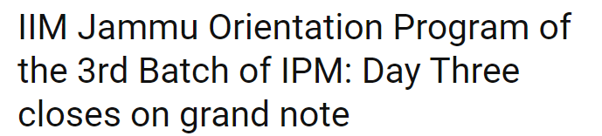
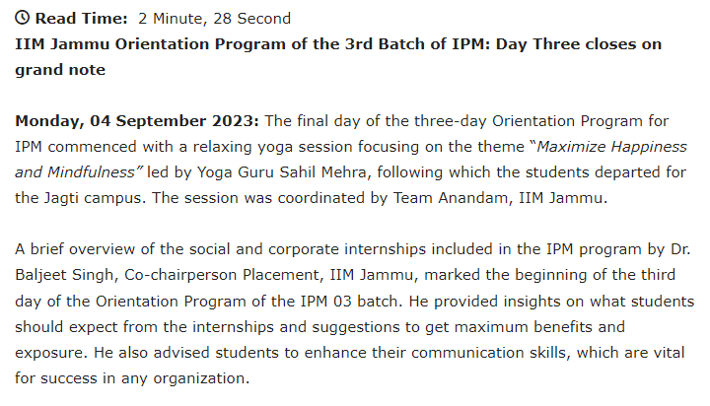
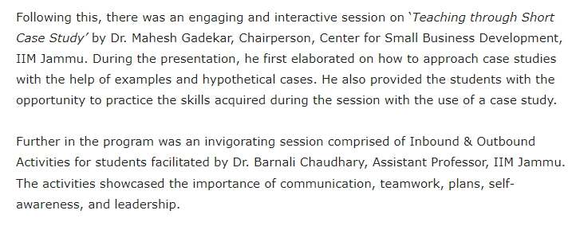
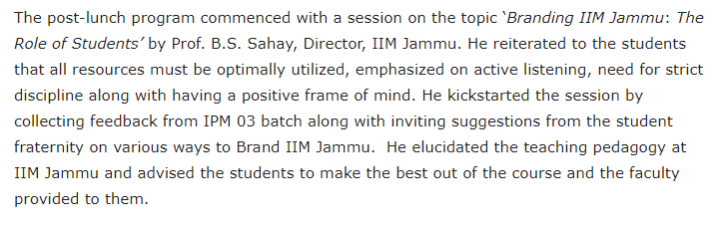
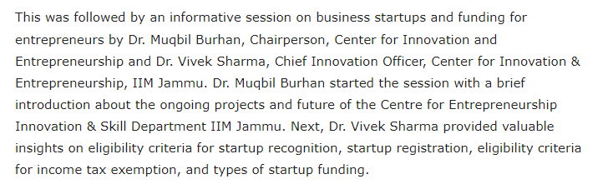
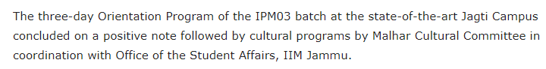
https://ibgnews.com/2023/09/04/iim-jammu-orientation-program-of-the-3rd-batch-of-ipm-day-three-closes-on-grand-note/

